**General Concept**

IOT : Internet Of Things is simply get everything connected through the internet network making it easy to be more intelligence by gathering information and statistics from all devices and control all of them through the internet only using your phone or your smart device.

Smart Home is Applicable in various aspect of our home and environment to suite our different preferences

• Comfort or Ease of Control • Entertainment

• Security • Convenience all time

• Life time personalization • User friendly

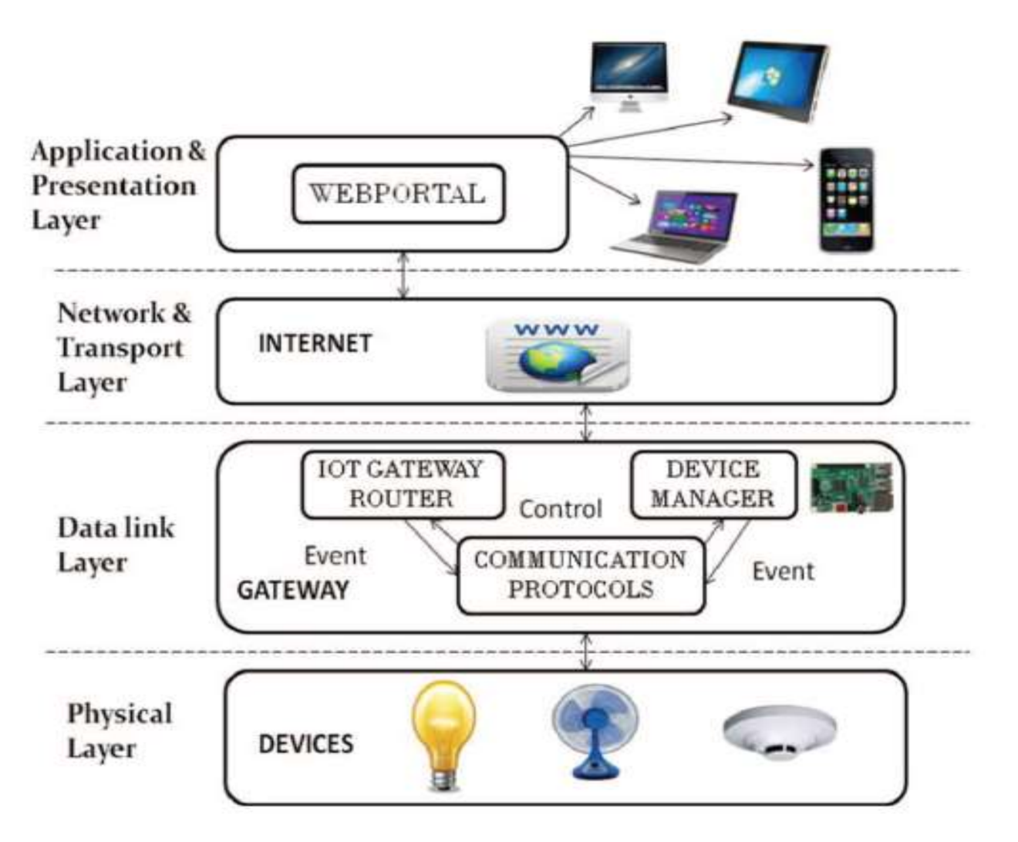

• The physical layer consists of the devices which are to be controlled.

• The data link layer consist of IOT gateway router, device manager and various communication protocols.

• The raspberry pi is used as the IOT gateway which communicates to personal computer or smart phone by means internet in the network and transport layer.

• The application and presentation layer consist of web portal which is nothing but designing a web page by which we can control the various appliances.

• The appliances can also be controlled by creating an app in mobile phone which is similar to web portal.

**MY Idea**

My idea is to create IOT system where electricity consumption , gas consumption and water consumption all monitored through sensors and give the user accurate details about consumption of each element and cost with time for each time any element is being consumed so we can help save our resources and money.

